FWM (Flexible Wall Membrane)

Product Specification Document

DATE: 25.07. 2019 REF: PL-CW-PSDFWM01

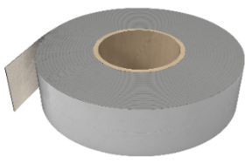
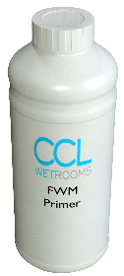

Detailed Description

FWM (Flexible Wall Membrane) has been developed for use onto walls, to provide waterproofing beneath ceramic, natural stone and porcelain tiles in bath/ shower rooms and other wet areas.

Pale blue, solvent free waterproof coating, suitable for use with Tilesure waterproofing and Decoupling Membrane or Screedsure waterproofing membrane. Junctions/ corners must be first reinforced with Reinforcing Tape as necessary.

System Components

FWM 8kg Tub
FWM Reinforcing Tape
FWM Primer

Features and Benefits

- Lifetime Guarantee
- Solvent free
- Quick and easy to apply
- Compatible with Tilesure and Screedsure
- Suitable for use on all commonly encountered substrates

Preparation

- All surfaces are to be clean, dry, free from dust, grease and oil, etc. Surfaces must be smooth, sound and flat, with all indentations filled with a suitable filler and all protrusions struck off
- Junctions/corners must be first reinforced with Reinforcing Tape as necessary

Application

- Single coat, brush or roller applied
- Coverage per coat (minimum 1 kg/m²)
- FWM-8: 8kg tub
- FWM should be applied to the walls of the shower area and overlapped onto the Tilesure Reinforcing Tape

Product specification

Product reference Code Size/Weight

FWM FWM-08 8kg

FWM Reinforcing Tape FWM-TAPE 10m

FWM Primer FWM-PR5 500ml

Manufacturer

Name: CCL Wetrooms

Contact Info: Address: Lodge Farm
Hook Road
North Warnborough
Hook
RG29 1HA

Tel: +44 (0)844 3276002 Fax: +44 (0)1256 765100
Web: www.ccl-wetrooms.co.uk Email: info@ccl-wetrooms.co.uk

