Linear Screed-Dec
& HBL-50

Product Specification Document

DATE: 25.07.2019 REF: PL-CW-PSDHBL01

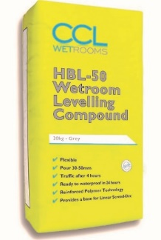
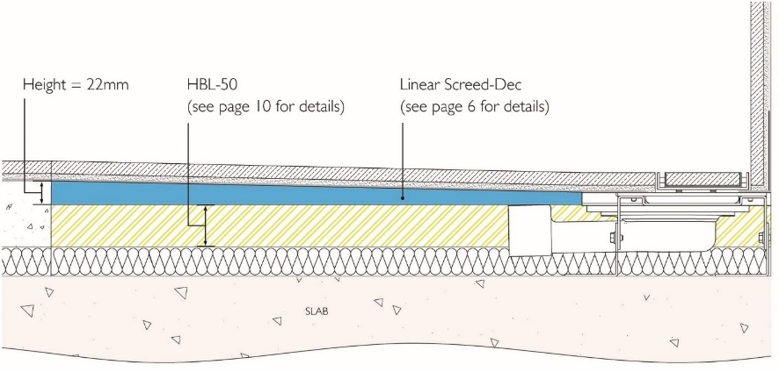

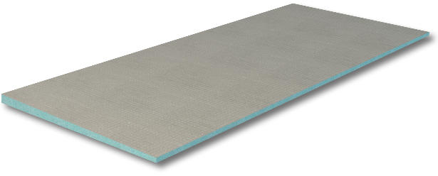

Detailed Description

The Linear Screed-Dec is a pre-formed tapered board with a high density extruded polystyrene (XPS) core and mineral coating, to be installed using HBL-50 Wetroom Levelling Compound.

System components

HBL-50 Wetroom Levelling Compound

Linear Screed-Dec

Linear Screed-Dec

Features and Benefits

- Has a built in one-way gradient, which removes the uncertainty of screeding a fall within the shower area by hand
- Lightweight and easy to handle
- Maintains good thermal properties and compressive strength
- Provides a guaranteed, constant gradient
- Can be tiled over – especially suitable for large format tiles
- Quick and easy to install
- Can be used to create a one-way fall towards the wall, a two-way fall with the drain just off the wall or in the centre of the shower
- Can be cut to size or used in combination with infill boards to suit any shower layout
- Versatile and can be installed into a variety of configurations. (Please note that additional components may be required for some of these – consult manufacturer for details)
- Can be provided with a brushed stainless steel tile trim
- Available in a range of sizes
- Comes with a Lifetime Guarantee.

Product Guidance

Board

Thickness: 22mm

Fall: 11mm

Options

Waterproofing Membrane:

CCL Wetrooms Tilesure Waterproofing & Decoupling Membrane or Screedsure Membrane, should be applied to the entire bathroom floor area. For larger bathrooms, Tilesure Waterproofing & Decoupling Membrane should be applied to a minimum of the shower area, plus an additional one metre in all directions.

FWM (Flexible Wall Membrane) should then be applied to the walls within the shower area only, to a minimum height of 2000mm and overlapped onto the Tilesure/ Screedsure Reinforcing Tape.

See separate Product Specification Document for full details.

Product Specification

Product reference Code Length Width

Linear Screed-Dec SDE-03 300mm 1200mm
SDE-05 500mm 1200mm
SDE-07 700mm 1200mm
SDE-08 800mm 1200mm
SDE-09 900mm 1200mm
SDE-10 1000mm 1200mm
SDE-11 1100mm 1200mm
SDE-12 1200mm 1200mm
SDE-15 1500mm 1200mm

SDE-H03 300mm 600mm
SDE-H05 500mm 600mm
SDE-H07 700mm 600mm
SDE-H08 800mm 600mm
SDE-H09 900mm 600mm
SDE-H10 1000mm 600mm
SDE-H11 1100mm 600mm
SDE-H12 1200mm 600mm
SDE-H15 1500mm 600mm

Tile Trim SDT-05 500mm
SDT-07 700mm
SDT-08 800mm
SDT-09 900mm
SDT-10 1000mm
SDT-11 1100mm
SDT-12 1200mm
SDT-15 1500mm

Infill Panel SIP-2

Used to fill in either side of the drainage component where the shower width exceeds 1200 mm.
Trimmable on site.

HBL-50

Features and Benefits

- Single component wetroom compound which uses fibre reinforced polymer technology
- Provides a stable base for the Linear Screed-Dec
- High build and self levelling, with good flow properties
- Allows for on-site tolerances within the substrate
- Rapid setting
- Trafficable after four hours, and ready to waterproof after 24 hours
- Poured to a datam 22mm less than the screed outside the shower area, typically to a depth of 30-50mm without the need for additional granite chippings
- Insulation layers can be installed underneath to complete the overall floor build-up
- Comes with a lifetime guarantee
- When the required depth exceeds 50mm, a suitable insulation board should be used to make up the difference, ensuring it is securely fixed to the substrate

Product Guidance

Compressive strength:

- After 1 day: 20.5 N/mm²
- After 7 days: 39.2 N/mm²

Flexural strength:

- After 1 day: 5 N/mm²
- After 7 days: 6.8 N/mm²

Product Specification

Product reference Code Weight

Wetroom Levelling compound HBL-50 20kg

Coverage: 3 m² per 20kg bag (approximately).
Consult manufacturer for details.

Manufacturer

Name: CCL Wetrooms

Contact Info: Address: Lodge Farm
Hook Road
North Warnborough
Hook
RG29 1HA

Tel: +44 (0)844 3276002 Fax: +44 (0)1256 765100
Web: www.ccl-wetrooms.co.uk Email: info@ccl-wetrooms.co.uk

