Linear Screed Line

Product Specification Document

DATE: 16.07.2019 REF: PL-CW-PSDLSL01

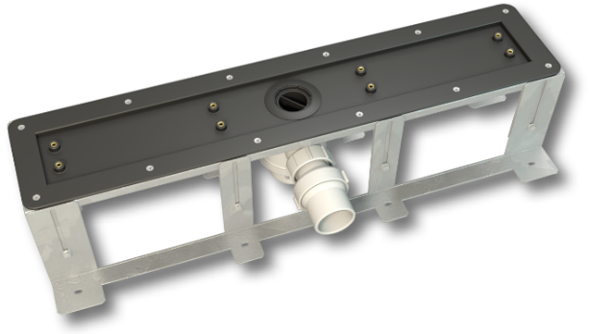

Detailed Description

The Linear Screed Line drain has been designed for concrete or screed floors and can be used on concrete slabs, planks and block and beam floors.

Versatility is its key feature, being available with one, two or three traps and a chance of horizontal and vertical outlets. The drain incorporates out TR50 trap which has a 50mm waterseal and is supported by a lifetime guarantee.

Available until a chance of stylish grill finishes, the Linear Screed Line will suit almost any application.

System Components

Drain Body
Linear Grill
Brackets

Features and Benefits

- Horizontal or vertical outlet
- Flow rate up to 68 L/min
- 50mm TR50 waterseal trap (manufactured to EN 274-1:2002)
- Height adjustable brackets and grill
- 360° rotatable outlet
- Variable trap positions (left, right and centre)
- Top access trap for easy maintenance
- Grill lengths available up to 2000mm
- Bespoke designs available on request
- Lifetime Guarantee.

Product Guidance

- Single, Double and Triple traps are available to cope with flow rates of up to 68 L/min
- All Linear Screed Line drains are manufactured with one trough size at 660mm and all lengths of grill are then fitted onto this trough
- The wall grill width is adjustable to allow for different wall thickness
- The height of the grill is adjustable in 1mm increments to suit tile thicknesses of between 6-20mm. Additional spacers are available on request for tiles thicker than 20mm
- Floor grill width: 58mm
- Wall grill width: 86mm
- All grills are manufactured from 1.4401 (316) grade stainless steel and are available in a solid, slotted, stone-infill or frameless finish
- All grill finishes are available in 15 standard lengths from 600mm–2000mm
- Bespoke grills can be manufactured for sizes that are in between or over standard sizes
- Fast track bespoke lengths manufactured and delivered in 3-4 days

Horizontal Trap

- 50mm Waterseal
- 40mm ABS pipe connection
- The horizontal trap incorporates an adjustable ball joint, allowing for ease of installation
- The trap can be positioned centre, left or right handed
- It is accessible from the top for cleaning and maintenance
- Standard brackets allow drain adjustment from 138mm–218mm

Vertical Trap

- 50mm Waterseal
- 50mm ABS pipe connection
- The vertical trap allows the outlet to be positioned through the slab and connected to a waste pipe below
- The trap can be positioned centre, left or right handed
- It is accessible from the top for cleaning and maintenance
- Standard brackets allow drain adjustment from 55-88mm
- Extra shallow brackets allow drain adjustment from 38-57mm

Options

Waterproofing Membrane
CCL Wetrooms Tilesure Waterproofing & Decoupling Membrane or Screedsure membrane is applied to the whole shower area plus an additional metre outside of the shower area. FWM (Flexible Wall Membrane) should applied to the walls of the shower area and overlapped onto the Tilesure/ Screedsure Reinforcing Tape specified separately).

Product Specification

Product reference Code Traps Flow Rate

Horizontal Trap

Drain Body with Standard Brackets LSL-1H/ST 1 24 L/min
Drain Body with Standard Brackets LSL-2H/ST 2 41 L/min
Drain Body with Standard Brackets LSL-3H/ST 3 68 L/min

Vertical Trap

Drain Body with Standard Brackets LSL-1V/ST 1 24 L/min
Drain Body with Standard Brackets LSL-2V/ST 2 41 L/min
Drain Body with Standard Brackets LSL-3V/ST 3 68 L/min

Drain Body with Extra Shallow Brackets LSL-1V/ES 1 24 L/min
Drain Body with Extra Shallow Brackets LSL-2V/ES 2 41 L/min
Drain Body with Extra Shallow Brackets LSL-3V/ES 3 68 L/min

Grill Type

Product reference Code Length Grill Finish

Linear Wall Grill SWG-600 600mm Add code for Grill Finish
SWG-700 700mm
SWG-800 800mm
SWG-900 900mm
SWG-1000 1000mm
SWG-1100 1100mm
SWG-1200 1200mm
SWG-1300 1300mm
SWG-1400 1400mm
SWG-1500 1500mm
SWG-1600 1600mm
SWG-1700 1700mm
SWG-1800 1800mm
SWG-1900 1900mm
SWG-2000 2000mm
SWG-FT Bespoke
SWG-BES Bespoke

Linear Floor Grill SFG-600 600mm Add code for Grill Finish
SFG-700 700mm
SFG-800 800mm
SFG-900 900mm
SFG-1000 1000mm
SFG-1100 1100mm
SFG-1200 1200mm
SFG-1300 1300mm
SFG-1400 1400mm
SFG-1500 1500mm
Grill Type

Product reference Code Length Grill Finish

Linear Floor Grill SFG-1600 1600mm
SFG-1700 1700mm
SFG-1800 1800mm
SFG-1900 1900mm
SFG-2000 2000mm
SFG-FT Bespoke
SFG-BES Bespoke
.

Grill Finish Type A - Solid grill, grained
stainless steel with 5mm
gap around the grill.

Type B - Oblong slots, three
rows of oblong slots in a
grained stainless steel finish.

Type C - Square holes, three
rows of squares in a grained
stainless steel finish.

Type S8 – Stone-infill grill. Allows a
section of tile to be inserted to
provide a sleek continuous finish.
Suitable for 6-8mm stone/
porcelain tiles.

Type S12 – Stone-infill grill.
Suitable for 10.12mm stone/
porcelain tiles.

Type S20 – Stone-infill grill.
Suitable for 18-20mm stone/
porcelain tiles.

Type F - Frameless grill, suitable
for use with natural stone and
porcelain tiles.

Manufacturer

Name: CCL Wetrooms

Contact Info: Address: Lodge Farm
Hook Road
North Warnborough
Hook
RG29 1HA

Tel: +44 (0)844 3276002 Fax: +44 (0)1256 765100
Web: www.ccl-wetrooms.co.uk Email: info@ccl-wetrooms.co.uk

