Modular Wet-Floor

Product Specification Document

DATE: 16.07.2019 REF: PL-CW-PSDMWF01

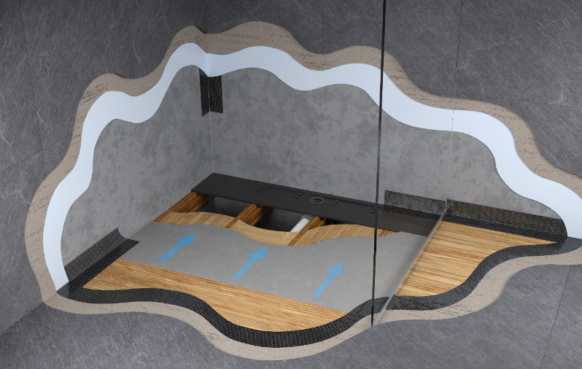

Detailed Description

The Modular Wet-Floor system can be used in a number of configurations to create a wetroom on a timber floor.

The system is versatile, cost effective and can be installed with the linear drain in either the centre of the shower area, or neatly positioned against the wall. Consisting of three main elements, the system is simple to configure.

System Components

- Drainage component manufactured from tough ABS plastic
- 1200 mm wide tapered board (22–11mm) manufactured from XPS foam with a mineral coating
- Floor or wall grill (1.4401 [316] grade stainless steel) to suit wetroom layout

Features and Benefits

- The drainage component and tapered boards can be easily trimmed on-site, making the whole system quick and easy to install. Two or more drainage components can be used to create larger shower areas.
- One or two way fall
- Create a shower area of any size
- Quick & easy to install
- Available with standard bottle trap or Lo-Seal waterless trap
- Centred, left or right handed trap position
- 360° rotatable outlet
- Flow rates of up to 68 L/min
- BBA Approved
- Height adjustable grill
- Grill lengths up to 2000mm
- Fast Track Bespoke service available – delivered in 3-4 days
- Lifetime guarantee

Product Guidance

- The wall grill width is adjustable to allow for different wall tile thicknesses
- The height of the grill is adjustable in 1mm increments to suit tile thicknesses of between 6–20mm
- Additional spacers are available on request for tiles thicker than 20mm
- Floor grill width: 58mm
- Wall grill width: 86mm
- All grills are manufactured from 1.4401 (316) grade stainless steel and are available in a solid, slotted, stone-infill or frameless finish
- All grill finishes are available in 15 standard lengths from 600mm – 2000mm
- Bespoke grills can be manufactured for sizes that are in between or over the standard sizes
- Fast track bespoke lengths manufactured and delivered in 3-4 days

Options

Waterproofing Membrane:
CCL Wetrooms Tilesure Waterproofing & Decoupling Membrane should be applied to the entire wetroom floor, extending at least an additional metre outside of the shower area.
FWM (Flexible Wall Membrane) should then be applied to the walls within the shower area only, to a minimum height of 2000mm and overlapped onto the Tilesure/ Screedsure Reinforcing Tape.
See separate Product Specification Document for full details.

Product Specification

Product reference Code Traps Flow Rate

TR50 Horizontal Trap MDC-1H 1 24 L/min
MDC-2H 2 41 L/min
MDC-3H 3 68 L/min

TR50 Vertical Trap MDC-1V 1 24 L/min
MDC-2V 2 41 L/min
MDC-3V 3 68 L/min

Waterless Trap MDC-W1 1 29 L/min
MDC-W2 2 56 L/min
MDC-W3 3 70 L/min

Product reference Code Length Width

Tapered Board MTB-03 300mm 1200mm
MTB-05 500mm 1200mm
MTB-07 700mm 1200mm
MTB-08 800mm 1200mm
MTB-09 900mm 1200mm
MTB-10 1000mm 1200mm
MTB-11 1100mm 1200mm
MTB-12 1200mm 1200mm
MTB-15 1500mm 1200mm

Product reference Code Length Width

Half Tapered Board MTB-H03 300mm 600mm
MTB-H05 500mm 600mm
MTB-H07 700mm 600mm
MTB-H08 800mm 600mm
MTB-H09 900mm 600mm
MTB-H10 1000mm 600mm
MTB-H11 1100mm 600mm
MTB-H12 1200mm 600mm
MTB-H15 1500mm 600mm

Tile Trim MTT-05 500mm
MTT-07 700mm
MTT-08 800mm
MTT-09 900mm
MTT-10 1000mm
MTT-11 1100mm
MTT-12 1200mm
MTT-15 1500mm

Grill Type

Product reference Code Length Grill Finish

Linear Wall Grill MWG-06 600mm Add code for Grill Finish
MWG-07 700mm
MWG-08 800mm
MWG-09 900mm
MWG-10 1000mm
MWG-11 1100mm
MWG-12 1200mm
MWG-13 1300mm
MWG-14 1400mm
MWG-15 1500mm
MWG-16 1600mm
MWG-17 1700mm
MWG-18 1800mm
MWG-19 1900mm
MWG-20 2000mm
MWG-FT Bespoke
MWG-BES Bespoke

Linear Floor Grill MFG-06 600mm Add code for Grill Finish
MFG-07 700mm
MFG-08 800mm
MFG-09 900mm
MFG-10 1000mm
MFG-11 1100mm
MFG-12 1200mm
MFG-13 1300mm
MFG-14 1400mm

Product reference Code Length Grill Finish

Linear Floor Grill MFG-15 1500mm Add code for Grill Finish
MFG-16 1600mm
MFG-17 1700mm
MFG-18 1800mm
MFG-19 1900mm
MFG-20 2000mm
MFG-FT Bespoke
MFG-BES Bespoke

Grill Finish Type A - Solid grill, grained
stainless steel with 5mm
gap around the grill.

Type B - Oblong slots, three
rows of oblong slots in a
grained stainless steel finish.

Type C - Square holes, three
rows of squares in a grained
stainless steel finish.

Type S8 – Stone-infill grill. Allows a
section of tile to be inserted to
provide a sleek continuous finish.
Suitable for 6-8mm stone/
porcelain tiles.

Type S12 – Stone-infill grill.
Suitable for 10-12mm stone/
porcelain tiles.

Type S20 – Stone-infill grill.
Suitable for 18-20mm stone/
porcelain tiles.

Type F - Frameless grill, suitable
for use with natural stone and
porcelain tiles.

Manufacturer

Name: CCL Wetrooms

Contact Info: Address: Lodge Farm
Hook Road
North Warnborough
Hook
RG29 1HA

Tel: +44 (0)844 3276002 Fax: +44 (0)1256 765100
Web: www.ccl-wetrooms.co.uk Email: info@ccl-wetrooms.co.uk

