Screedsure Waterproofing Membrane

Product Specification Document

DATE: 12.09. 2019 REF: PL-CW-PSDSS01

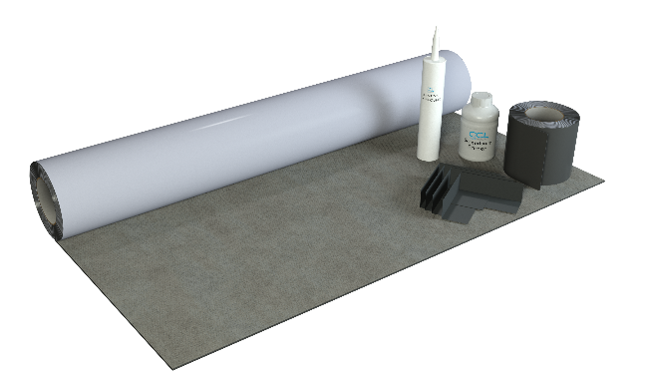
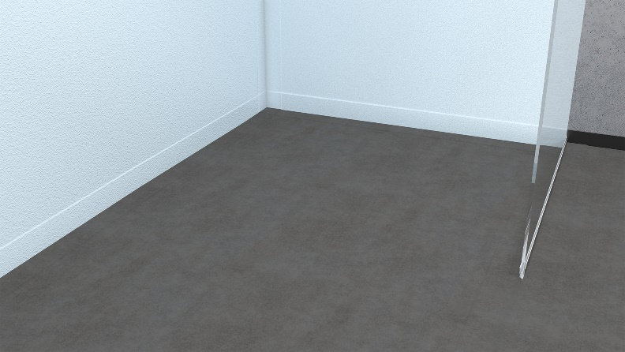

Detailed Description
Screedsure is a copolymer self-adhesive waterproofing membrane specifically designed for use onto screeded and other solid floors.
Developed for use in bathrooms, wetrooms and similar wet areas. Screedsure is comprised of a 1mm butyl based membrane, with a fabric top layer providing an excellent surface for the adhesion of natural stone, porcelain and ceramic tiles.
Screedsure is quick and easy to apply, providing a consistent waterproof layer that is guaranteed not to leak. It also provides an effective barrier to the transition of water vapour.

System Components

Screedsure Membrane
Screedsure Primer
Screedsure Reinforcing Tape
Screedsure Jointing Compound
Screedsure Pre-formed Corners

Features and Benefits

- Lifetime Guarantee
- Suitable for concrete, including gypsum based anhydrite screeds
- Self-adhesive – quick and easy to apply
- Ready to tile immediately
- Ideal for fast track construction
- Supplied as a complete kit
- Suitable for use with electric underfloor heating upto 150kw/m²
- 1mm factory controlled thickness
- Compatible with silicone sealants & stone sealers
- Compatible with wet underfloor heating systems, provided the pipework does not come into direct contact with the membrane

Product Guidance

Thickness:

1.0mm.

Primer:

All surfaces to be primed with Screedsure Primer.

Joints:

Butt joint: 1–2 mm gap. All butt joints in the membrane, wall-to-wall and wall-to-floor interfaces and at pipe entries to be sealed with Screedsure Jointing Compound, gun applied. All small gaps or voids around pipe entries, etc, to be filled with Screedsure Jointing Compound (JC2).

Accessories:

- Screedsure Reinforcing Tape to reinforce all wall junctions, butt joints and other detail work in membrane.
- SSM-K5: 5m² kit contains 5 x 1m roll of membrane; 10m Reinforcing Tape; 500ml Primer; 290ml Jointing Compound.
- SSM K-10: 10m² kit contains 10 x 1m roll of membrane; 15m Reinforcing Tape; 1L Primer; 290ml Jointing Compound.

Options

Waterproofing Membrane:

CCL Wetrooms Tilesure Waterproofing & Decoupling Membrane or Screedsure Membrane, should be applied to the entire bathroom floor area. For larger bathrooms, Tilesure Waterproofing & Decoupling Membrane should be applied to a minimum of the shower area, plus an additional one metre in all directions.
FWM (Flexible Wall Membrane) should then be applied to the walls within the shower area only, to a minimum height of 2000mm and overlapped onto the Tilesure/ Screedsure Reinforcing Tape.
See separate Product Specification Document for full details.

Product Specification

Product reference Code Size Description

Screedsure Kit SSM-K5 5m² 5m x 1m Roll of Membrane
10m Reinforcing Tape
500ml Primer
290ml Jointing Compound

Screedsure Kit SSM-K10 10m² 10m x 1m Roll of Membrane
15m Reinforcing Tape
1L Primer
290ml Jointing Compound

Product reference Code Size Description

Additional separate items

Pre-formed Corner PFC-INT Internal Corner
PFC-EXT External Corner

Reinforcing Tape SSM-T10 10m
SSM-T15 15m

Primer SSM-PR5 500ml
SSM-PR10 1L

Jointing Compound SSM-JC2 290ml

Manufacturer

Name: CCL Wetrooms

Contact Info: Address: Lodge Farm
Hook Road
North Warnborough
Hook
RG29 1HA

Tel: +44 (0)844 3276002 Fax: +44 (0)1256 765100
Web: www.ccl-wetrooms.co.uk Email: info@ccl-wetrooms.co.uk

.

