Tilesure Waterproofing & Decoupling Membrane

Product Specification Document

DATE: 25.07. 2019 REF: PL-CW-PSDTS01

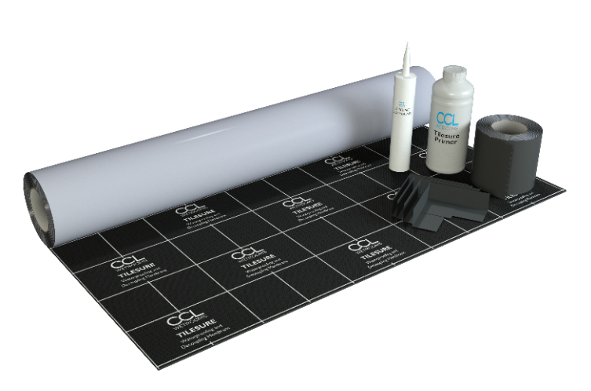

Detailed Description
Tilesure is a heavy duty self-adhesive waterproofing and decoupling membrane designed for use onto timber and solid floors. It has been developed specifically for use in bathrooms, wetrooms and similar wet areas.
Tilesure is comprised of a 1.4mm butyl based membrane, with a copolymer top layer which provides an excellent surface for the adhesion of natural stone, porcelain and ceramic tiles.
Tilesure acts as a decoupling membrane by uncoupling the floor tiles and accommodating movement in the substrate within a thickness of only 1.4mm. This omits the requirement for a traditional decoupling mat. Tilesure also provides an effective barrier to the transition of water vapour.

System Components

Tilesure Membrane
Tilesure Primer
Tilesure Reinforcing Tape
Tilesure Jointing Compound
Tilesure Preformed Corners

Features and Benefits
- Lifetime Guarantee
- Decoupling properties of up to 12mm
- Self-adhesive – quick and easy to apply
- Suitable for timber and solid floors including gypsum based anhydrite screeds
- Ready to tile immediately
- Suitable for use with electric underfloor heating systems upto 150kw/ m²
- Compatible with wet underfloor systems, provided the pipework does not come into direct contact with the membrane.
- 1.4mm factory controlled thickness
- Compatible with silicone sealants & stone sealers

Product Guidance

Thickness
1.4mm.

Primer

All surfaces to be primed with Tilesure Primer (PR2)

Joints

Butt joint: 1–2 mm gap. All butt joints in the membrane, wall-to-wall and wall-to-floor interfaces and at pipe entries to be sealed with Tilesure Jointing Compound, gun applied. All small gaps or voids around pipe entries, etc, to be filled with Tilesure Jointing Compound (JC2).

Accessories

- Tilesure Reinforcing Tape to reinforce all wall junctions, butt joints and other detail work in membrane.
- TSM-K5: 5m² kit contains 5 x 1m roll of membrane; 10m Reinforcing Tape; 500ml Primer; 290ml Jointing Compound.
- TSM K-10: 10m² kit contains 10 x 1m roll of membrane; 15m Reinforcing Tape; 1L Primer; 290ml Jointing Compound.

Options

Waterproofing Membrane:

CCL Wetrooms Tilesure Waterproofing & Decoupling Membrane or Screedsure Membrane, should be applied to the entire bathroom floor area. For larger bathrooms, Tilesure Waterproofing & Decoupling Membrane should be applied to a minimum of the shower area, plus an additional one metre in all directions.
FWM (Flexible Wall Membrane) should then be applied to the walls within the shower area only, to a minimum height of 2000mm and overlapped onto the Tilesure/ Screedsure Reinforcing Tape.
See separate Product Specification Document for full details.

Product specification

Product reference Code Size Description

Tilesure Kit TSM-K5 5m² 5m x 1m Roll of Membrane
10m Reinforcing Tape
500ml Primer
290ml Jointing Compound

Tilesure Kit TSM-K10 10m² 10m x 1m Roll of Membrane
15m Reinforcing Tape
1L Primer
290ml Jointing Compound

Product reference Code Size Description

Additional separate items

Pre-formed Corner PFC-INT Internal Corner
PFC-EXT External Corner

Reinforcing Tape TSM-T10 10m
TSM-T15 15m

Primer TSM-PR5 500ml
TSM-PR10 1L

Jointing Compound TSM-JC2 290ml

Manufacturer

Name: CCL Wetrooms

Contact Info: Address: Lodge Farm
Hook Road
North Warnborough
Hook
RG29 1HA

Tel: +44 (0)844 3276002 Fax: +44 (0)1256 765100
Web: www.ccl-wetrooms.co.uk Email: info@ccl-wetrooms.co.uk

.

